Rapid Start
The fastest way to upgrade your learning is to clear your path of any obstacles. The Rapid Start lessons are designed to do just that!
Overview and recommendations
Key dimensions | Self-management, mindset
Recommended pace | Most learners see best results with 2 to 3 hours of theory across 1 to 2 weeks.
Recommended practice | Most learners see best results with a combined 1 to 2 weeks of practice. You will continue using these skills for a long time.
Progression notes | Accumulate 2 to 3 focus tasks by going through lessons, then practice until the tasks are completed before moving through remaining lessons. This progression should take approximately 1 to 2 weeks.
How this stage helps you
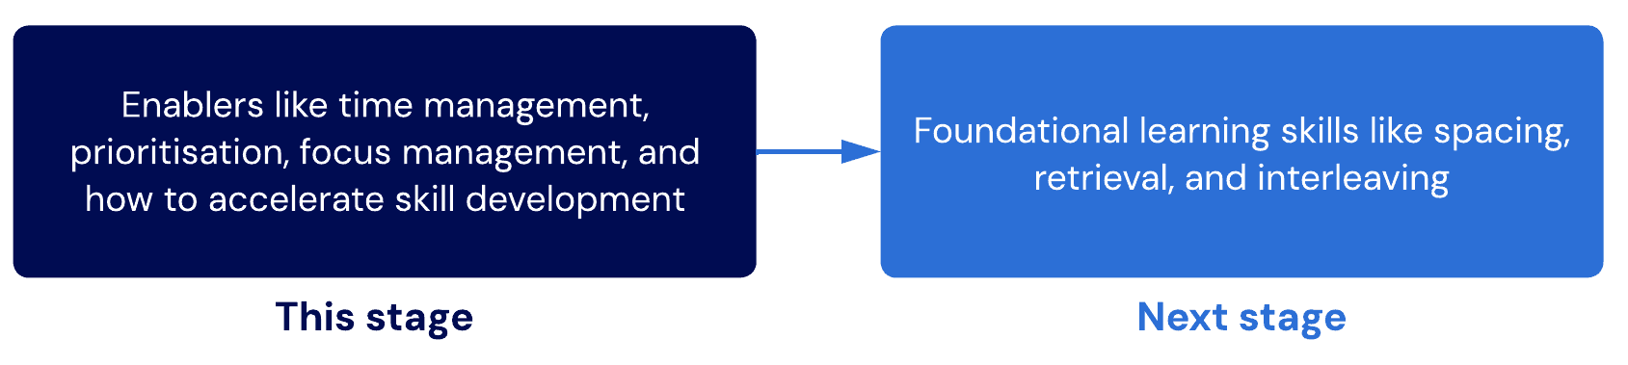
This stage will focus on improving your enabler skills. Working on these skills improves your ability to work through the program and accelerates your development speed.
Lessons
- Introduction to Rapid Start
A brief introduction to get you moving at full speed!
- Rapid time management
An overview of some of the most critically important principles for effective and sustainable time management.
- Rapid Google Calendar tutorial
It isn't rocket science, but learning to use your calendar could take you to the moon.
- Rapid procrastination tips
Quick tips to knock procrastination on its head!
- Intermediate procrastination techniques
A more comprehensive overview of how to overcome procrastination, if it seriously affects you.
- Intermediate procrastination techniques 2
Introducing a framework for helping you to take action and reduce procrastination.
- Increasing your success rate
In this lesson, we'll introduce three principles that we discovered boosted the success rate of learning new skills by 80% for our students.
Sub-lessons
- Accessing the growth zone
- Rushing
- Selective learning

- Introduction to Rapid Start
The purpose of Rapid Start
Spending time to unblock our future barriers is crucial to learning new skills quickly. Unfortunately, it's a step that is often overlooked. As a result, learners can encounter more obstacles than needed. This can be frustrating and eventually demotivating as overcoming each obstacle takes time, energy, and attention away from making further strides.
Key principle
It's always worth investing time now to make things easier for yourself later. Your future self will have their hands full. Finding ways to make it easier for ourselves later means we give ourselves the space to adapt and overcome new and harder challenges.
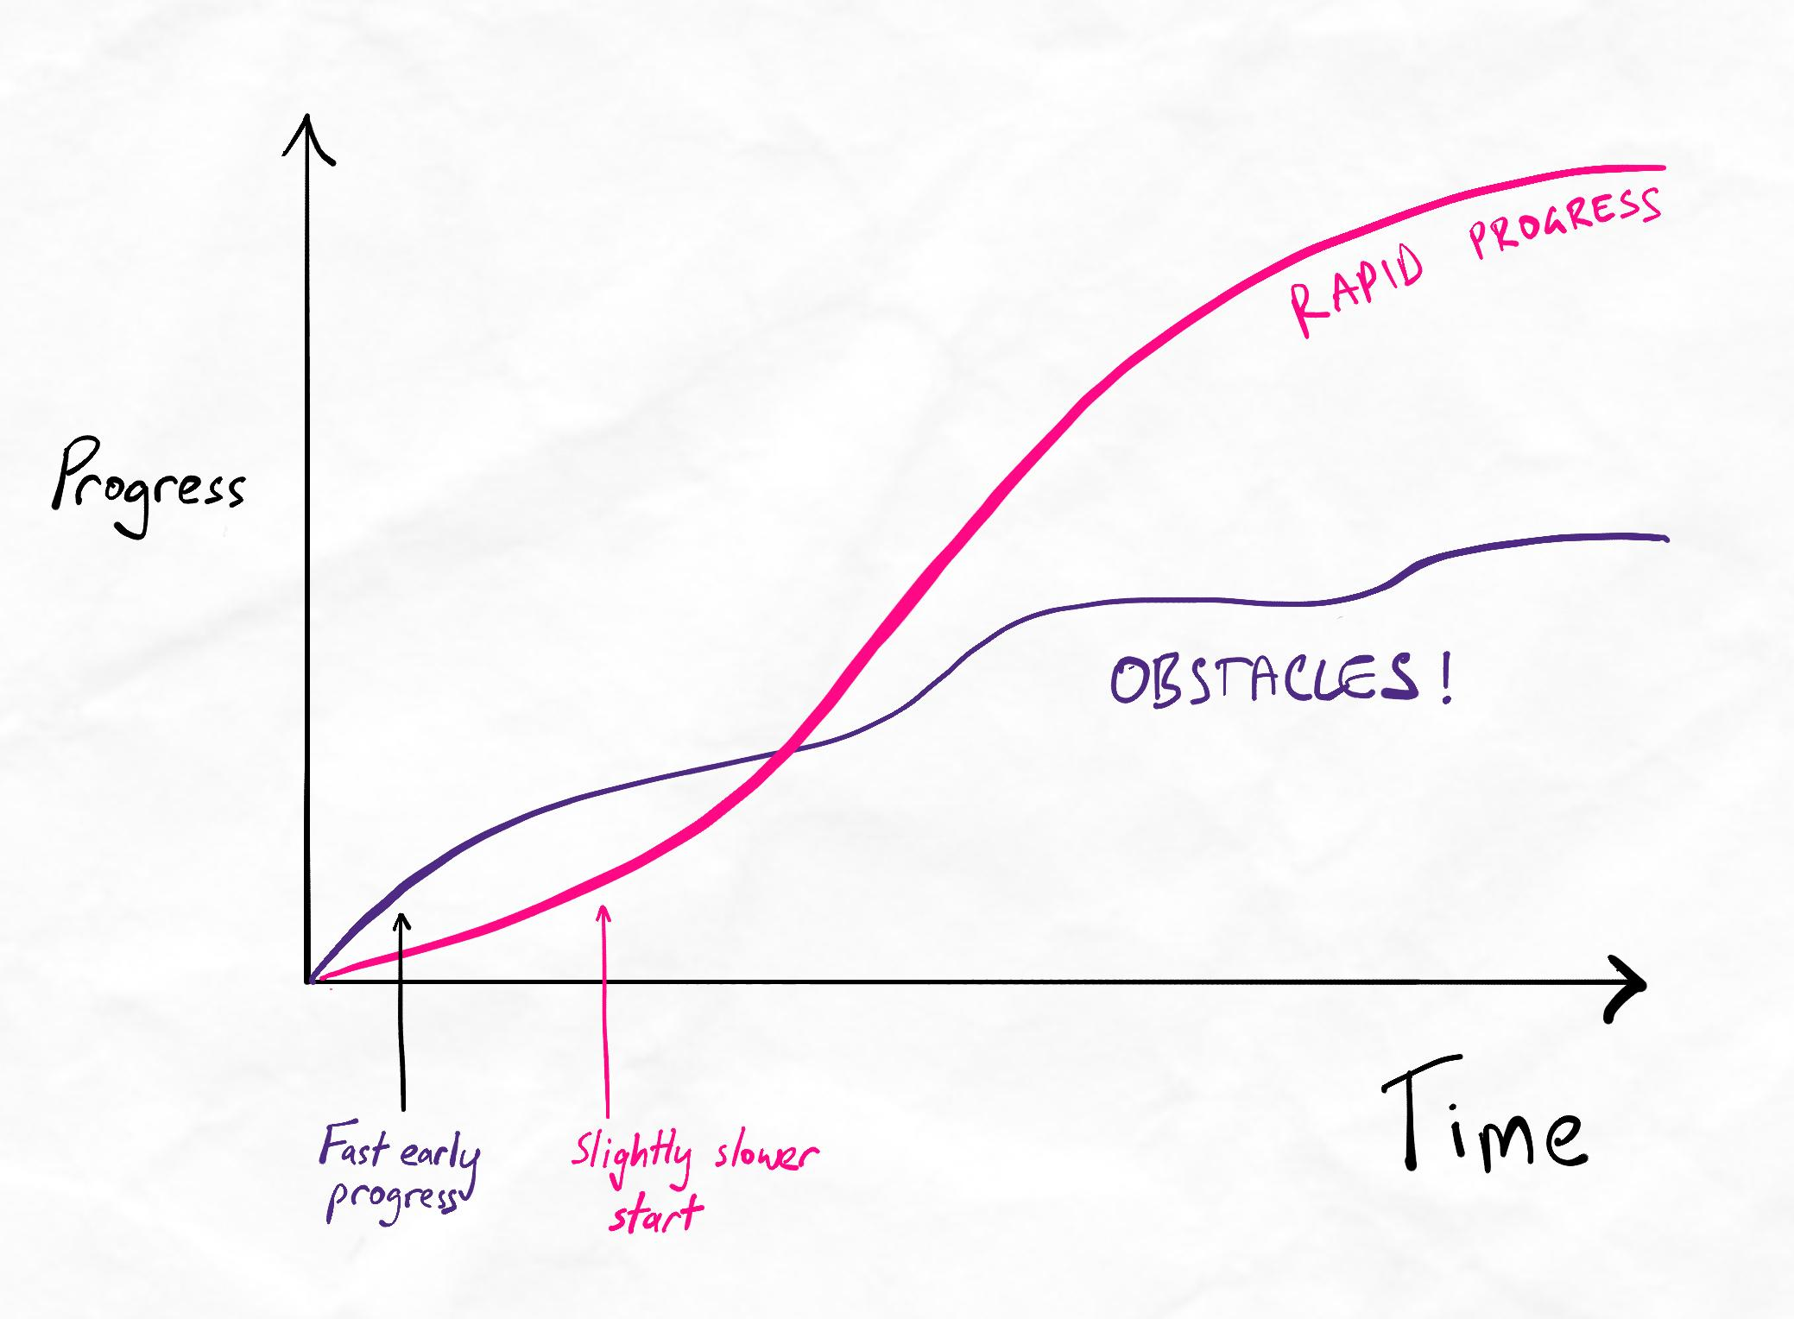Removing obstacles early on allows rapid progress later.

2. Rapid time management
Core concepts
- Urgency trapping
- Task management vs. time management
- Human biological tendencies for prioritisation and how it harms us
- Urgency vs importance
- The life-changing value of prioritising “importance” instead of “urgent”
- Theory time vs. practice time
We'll explore these concepts in more depth later in the program. You can read our article here on recommended apps for time management, task management and note-taking. You can also find this article again anytime from the Learning Support page on the left-side menu.
Key principle
Always practice often, early, and with increasing challenges. Learning and time management are skills. And skills are about what you can do, not what you know. One of the most common reasons people struggle to acquire new skills is when there is too much theory and insufficient practice.
Recommended tasks
Make sure to complete our recommended tasks whenever you see them! Each task is designed to turn theory into practice. Remember, skills are only helpful if we can use them.
Recommended tasks
Add tasks to your focus list so you can practice the skills.
Dimensions
Rapid Start
Fix urgency trapping
  - Identify any tasks that take up a significant amount of your time because they are urgent but not necessarily important. Remember, a task is important if the consequence of failure is unacceptable and unmanageable.
  - Next, identify tasks that you know are important but not urgent. These tasks could make a big difference in the medium to long term. Remember to include "learning to learn"!
  - Set time in your schedule to work on the important, non-urgent tasks regularly. Your urgent tasks should fit around this.

3. Rapid Google Calendar tutorial
The dangers of overscheduling
Many people pack their schedules too ambitiously because they have lots to do. Unfortunately, a full schedule means nothing if you cannot follow it.
Overscheduling is problematic for multiple reasons:
- It creates an illusion of productivity. What matters is what you completed, not what you scheduled.
- It makes it harder to assess your true workload capacity. This makes it harder to gradually improve as you don't know where your limits truly are.
- It makes planning more difficult because your ability to estimate how long it will take to complete tasks is inaccurate.
- It creates the undesirable psychological impact of getting used to falling behind and struggling to catch up. This is not a positive mindset that fosters high-quality work and well-being.
Key principle
Schedules become useless when you cannot follow them. Always start by scheduling with a relaxed and manageable timing. Then, fit more tasks and events as your time management skills improve. Overscheduling reduces productivity while making improvement more difficult.
Make time for fun
It's also essential to schedule relaxation and fun activities, especially when busy. The human brain is not a tireless machine. When we're busy, it's easy not to schedule relaxation time in our day because we want to get more things done.
Unfortunately, this can have a detrimental effect. It can lead to more unintentional breaks in the form of procrastination, which ultimately causes us to fall behind on our schedule and makes us feel guilty. Over time, trying to adhere to an over-full schedule can contribute to burnout. Instead, scheduling a dedicated time daily to unwind and relax can help us retain focus and energy during the day when we need to be productive.
Key principle
Even the most productive people aren't machines. Schedule time for breaks and relaxation during busy days. This ensures we are rested, energised, and focused.
Recommended tasks
Make sure to complete our recommended tasks whenever you see them! Each task is designed to turn theory into practice. Remember, skills are only helpful if we can use them.
Recommended tasks
Add tasks to your focus list so you can practice the skills.
Dimensions
Rapid Start
Schedule time for iCanStudy theory using good time management principles
Let's set up for success! Create a simple schedule for when you will cover theory through our iCanStudy program weekly or fortnightly.
We recommend between 1 to 3 hours per week of theory. Remember that practice should happen by gradually replacing your existing methods with the new techniques you learn.
If you spend more than 20 hours per week learning, you may be able to manage up to 5 hours per week of theory before risking overload.
When scheduling, remember to keep in mind:
  - Urgency trapping and why you should time-box important tasks (like upgrading your learning with our program)!
  - The dangers of overscheduling. Keep your schedules easily manageable at first.
Occasionally, you may learn a technique that requires extra time investment per week, such as a daily reflection. Ensure you time-box these to an appropriate amount of time to stay consistent and achieve your schedule.

4.Rapid procrastination tips
Anti-procrastination tips
- Make a list and break it down. Breaking down tasks reduces the risk of being overwhelmed. Making tasks more specific also helps us focus.
- Set yourself up for success. Our behaviours are shaped by our environment so start shaping your environment.
- Get started beforehand. Lean into your perfectionist tendencies and get the ball rolling.
- Group up. Leverage social pressure to keep ourselves accountable.
- Aim for a personal best. Meet yourself where you are and aim to push one step higher. No one is perfect, but everyone can do their best.
Remember, these tips are only a quick introduction to get you started. We will cover many more techniques later throughout the course.
Recommended tasks
Make sure to complete our recommended tasks whenever you see them! Each task is designed to turn theory into practice. Remember, skills are only helpful if we can use them.
Recommended tasks
Add tasks to your focus list so you can practice the skills.
Dimensions
Rapid Start
Schedule time for iCanStudy theory using good time management principles
Let's set up for success! Create a simple schedule for when you will cover theory through our iCanStudy program weekly or fortnightly.
We recommend between 1 to 3 hours per week of theory. Remember that practice should happen by gradually replacing your existing methods with the new techniques you learn.
If you spend more than 20 hours per week learning, you may be able to manage up to 5 hours per week of theory before risking overload.
When scheduling, remember to keep in mind:
  - Urgency trapping and why you should time-box important tasks (like upgrading your learning with our program)!
  - The dangers of overscheduling. Keep your schedules easily manageable at first.
Occasionally, you may learn a technique that requires extra time investment per week, such as a daily reflection. Ensure you time-box these to an appropriate amount of time to stay consistent and achieve your schedule.

5. Intermediate procrastination techniques
Procrastination
Dealing with procrastination
Many people deal with procrastination with unsustainable solutions. People attribute their procrastination to a lack of motivation. However, this leads them to become trapped in a cycle of fluctuating motivation, which leads to burnout over time.
There's no such thing as procrastination
When we give procrastination a name, it can prevent us from tackling the issue effectively. Procrastination can occur due to many different reasons. Each trigger and response can have different solutions. To end procrastination, we must be specific in what behaviour we are trying to change and what causes this behaviour.
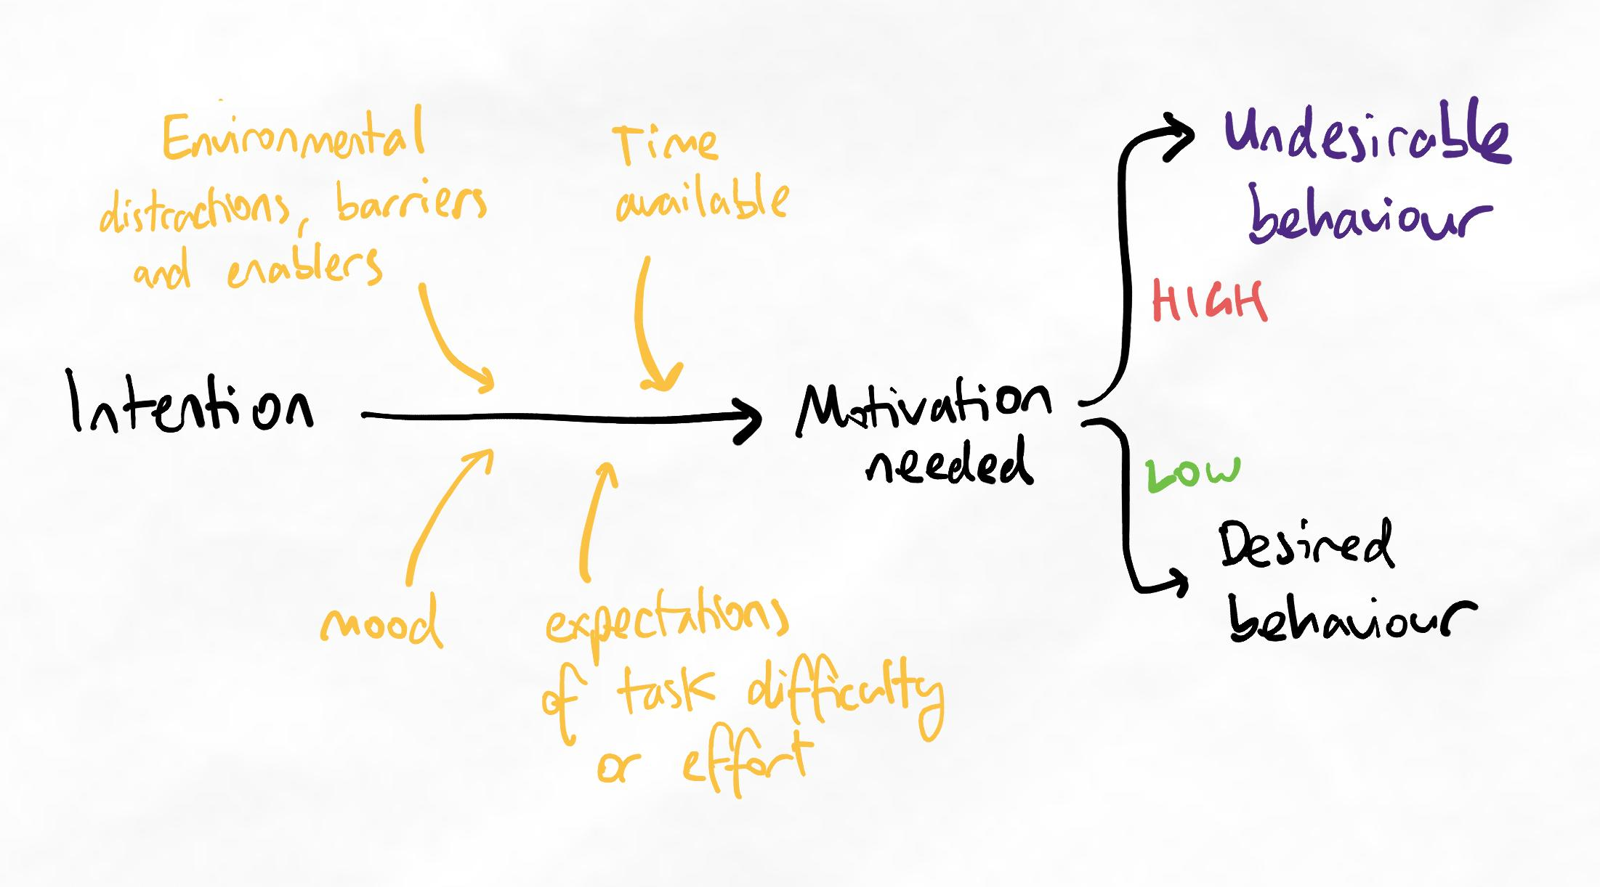When the motivation needed is high, we are less likely to be able to complete the task consistently.
The nature of motivation
Motivation always fluctuates because many variables influence it. Your plans must allow you to achieve your goals even on a bad day with low motivation.
What influences motivation?
- Mood
- Sleep quality and energy
- Interest or curiosity in the activity
- Sense of purpose
- Punishments and rewards
- Sense of voluntariness and autonomy
- Alignment with identity and values
- Competence at activity
- Psychological reserve
- Physical well-being
Willpower-dependent vs willpower-enhanced

You can see how the solution to address one factor can be dramatically different to another. It is also unrealistic to assume all of these factors can be perfectly controlled on a daily basis. Instead, we must rely on habits and environments to move us into auto-pilot. By doing so, we can become willpower enhanced, rather than willpower dependent.

Willpower dependent | Willpower enhanced
Relies on motivation and willpower to take action | Relies on habits and environment to make taking action frictionless
Productivity depends on motivation | Productivity depends on habits
Inconsistent | Highly consistent
Leads to burnout | Prevents burnout
Low reserve for when unexpected challenges arise. | Able to utilise willpower when challenges increase to push through and overcome them.
Finish Lesson

6.Intermediate procrastination techniques 2
BEDS-M
Note
This lesson is originally from Technique Training, later in the program. It has been brought forward due to popular demand. If procrastination is not a serious issue for you, you can skip this lesson and cover it during Technique Training instead.
BEDS-M is a highly effective framework for improving focus. However, not every component is of equal importance. Below, we will recap on each item as well as indicate its relative impact.
BEDS-M
Burnt ships strategy
What is it?
The burnt ships strategy has been referred to in several historical contexts by generals and conquistadors. In summary, the strategy is to burn your transport ships after using them so you have no path of retreat.

How do we use it?
For improving focus in our mundane (not going to war) lives, this strategy translates to setting high consequences of failure for tasks.
For example, some learners have formed accountability pairs where the consequence of failure is to stand up and shout in the middle of a crowded hall during school or lectures.
Note: we are not recommending you start screaming in a crowded hall...

How useful is it?
This strategy is a useful adjunct to other methods when other methods alone are not enough. While it can seem like a fun and exciting strategy, it is more suited for short-term change. It is less effective in the long-term than the other methods.
This is because it operates at the "consequence" level of behavioural psychology. Changing behaviours through "consequence" is generally either not sustainable or simply inadequate if other elements are not addressed.
Use this strategy when other methods seem insufficient or when there are certain behaviours that are a high, urgent priority to change.
Important considerations
- The consequence of failure must be high enough that you are genuinely fearful of it. Social challenges involving embarrassment have been reported to be effective by other members.
- The consequence must be enforced. Accountability buddies are helpful and recommended.

Environment

What is it?
If there is a cookie jar in front of someone who loves cookies, it takes a lot of motivation and willpower to refrain from eating it. Even someone who feels so-so about cookies may be tempted to eat them. On the other hand, controlling your environment means removing the cookie jar, and therefore the need to use motivation and willpower in the first place.
Some of you feel tempted to eat a cookie just from seeing this photo...

How do we use it?
You must make your environment conducive to success, which requires you to remove anything that may cause procrastination.
Removing distractions is much easier and more productive than resisting distractions using your willpower.

How useful is it?
This strategy is potentially the most powerful of all. In many cases, this strategy alone is enough to change behaviours permanently.
The latest research on behavioural psychology indicates that modifying our environment is one of the biggest influencers to sustainable and successful behaviour change. To make productive and meaningful changes to our environment, pair this strategy with the Distraction cheat sheet.
Distraction cheat sheet
What is it?
A simple sheet of paper where you can track distractors. Over time, this allows you to make adjustments to your environment to remove them.

How do we use it?
Have a piece of paper next to you while you are studying. Whenever you become distracted while studying, write that distraction onto your distraction cheat sheet. Then, when you are setting up the environment, you refer to this cheat sheet to eliminate any new distractions.

How useful is it?
This strategy is primarily effective when paired with environment optimisation. However, there is an additional benefit of increasing awareness of what affects your focus, which can improve your general focus self-regulation.

Scheduling
What is it?
It's a schedule.

How do we use it?
Please refer to the scheduling lessons earlier to learn how to set up a basic, sustainable schedule.

How useful is it?
When used correctly and sustainably, schedules improve our ability to focus at a psychological level. This is likely due to:
- Improved clarity over tasks and events
- Reduced cognitive burden of decision-making
- Reduced flow disruption
- Reduced context switching, which has significant cognitive switching penalty effects
A basic schedule is a core tool for any learner, even if set loosely.

Minimum viable goals (MVG)
What is it?
These are the easiest and most achievable goals needed to accomplish larger goals. The key is the word "minimum". MVGs must be the smallest possible action step where the motivation required is as close to zero as possible.

How do we use it?
- Start with a larger desired behaviour
- Identify the steps needed to begin engaging in the desired behaviour
- Break down the steps until you get to a point where it feels so easy that being unable to achieve it feels ridiculous
For example, a chain of MVGs for moving from the couch to the study desk may be:
- Take a single deep breath and look out the window.
- Take 3 more breaths
- Stand up
- Walk to your study room
- Sit at your desk
- Take out your studying material
- Study for 2 minutes
Note that better environment set-up makes MVGs easier as there are fewer barriers.

How useful is it?
MVGs help train out existing bad habits and train new ones. For some firmly ingrained habits, you may only be able to chain 2 or 3 MVGs together before giving up and reverting. However, consistent exposure allows marginal improvement until it becomes easier to get closer to the desired behaviour.
MVGs alone are usually insufficient when the environment is not prepared.

Putting procrastination to bed
Below are some high-priority recommended tasks that anyone can implement more of in their lives. Not every item in BEDS-M has been covered here. The tasks are focused on Environment and Distractions sheet because these are two of the most versatile and powerful adjustments.
If you want to add your own tasks to help turn theory into practice, go to your dashboard after finishing this lesson and add a custom task!
Use custom tasks to keep yourself on track with action items you want to put into practice (even if a recommended task isn't given).

Recommended tasks
Add tasks to your focus list so you can practice the skills.
Dimensions
Rapid Start
Optimise your environment and refine it with a Distraction sheet
Turn your environment into a powerful focus zone.
  - Write down a list of things that distract you. They could be physical things, digital distractions, or even people.
  - Write down a list of changes you could make to your environment to remove the distractions or deter/inform people to help you focus.
  - Make the changes to your environment as best you can.
  - Next time you have a focused session, note any distractions on your distractions sheet.
  - Adjust your environment again based on your distractions sheet.
Repeat this process for at least three sessions. By this point, you should have made some high-yield changes to take control of your focus.
Remember to share your experience and get ideas for how you can optimise your environment in our supportive and helpful community!
Tip:
To take this to another level, attempt to use MVGs next time you feel like procrastinating and write down any barriers you encounter on your distractions sheet. For example, maybe you didn't have all the right tabs open, which caused you to feel like procrastinating.
This way, you can continue refining your environment with positive influences to make your path to focus as frictionless as possible while removing the negative distractors!

7.Increasing your success rate
Over the past decade, we've identified 3 behaviours and principles that dramatically increased our learners' chances of successfully learning new skills. Explore the sublessons below to dive into each of them.
Table of contents
Sublesson
- Accessing the growth zone
- Rushing
- Selective learning

  - Accessing the growth zone
Key principles
- Beware of the reversion response to fear
- Challenging goals require additional skills
- Developing skills require navigation through the fear zone
- Beware of the misinterpreted-effort hypothesis
- Aim to develop a growth mindset with the strategies at the end of this lesson
The journey to learn new skills
Many people spend too long on becoming 100% certain about the theory before attempting to use skills and gain real experience. This is detrimental to learning and can cause a common issue of information over experimentation.
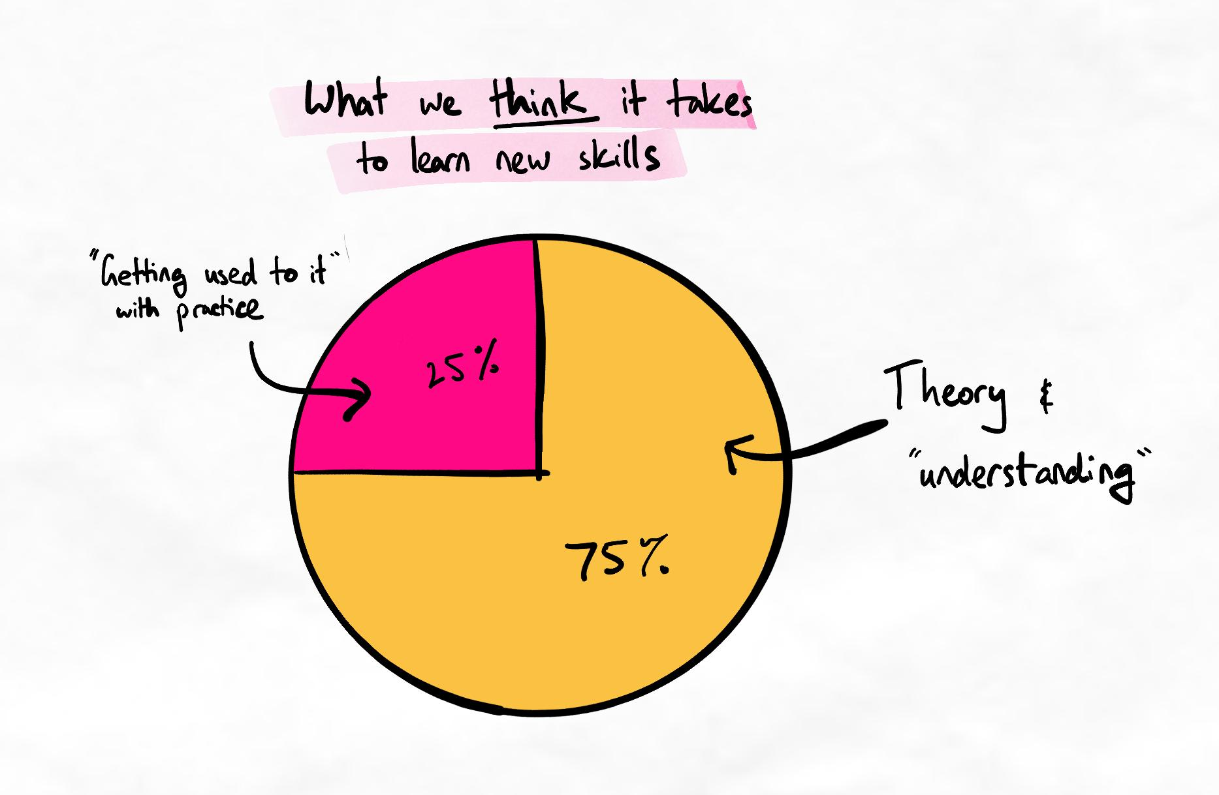An oversimplified view of what many people think learning new skills involves.
In reality, practice is essential to give relevance to theory. Our questions become more targeted, and we can enter the theory-practice cycle, which is the engine for skill development. When the theory-practice cycle is delayed or infrequent, skill development is slow and ineffective.
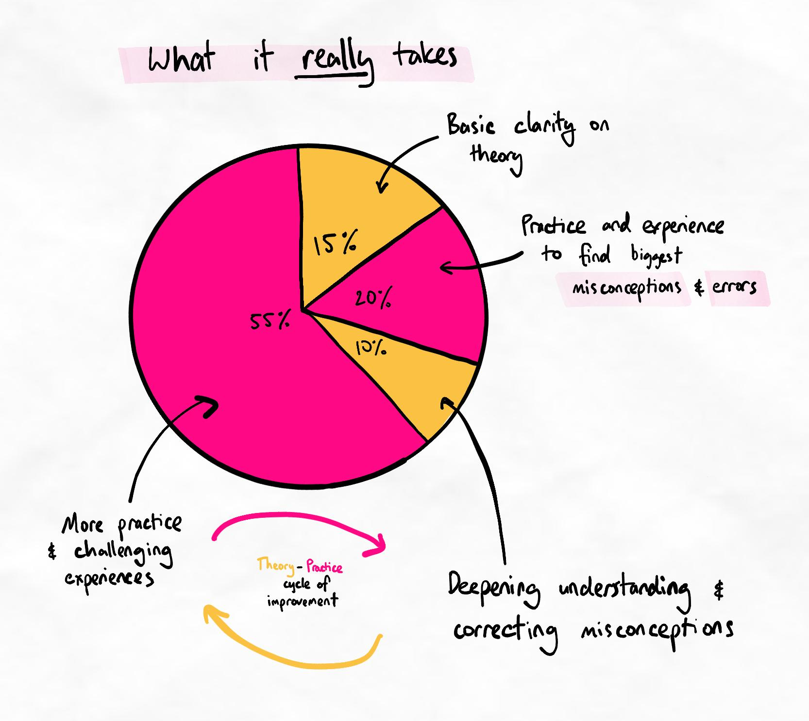Learn more about the theory-practice cycle here.
Supplementary modules
If accessing the growth zone is a significant barrier, complete our 30-day mindset challenge! Find it in the supplementary modules on your dashboard.
  - Rushing
Key principles
- Rushing is often due to insufficient time invested into practice
- Rushing almost always leads to failure (usually while being overconfident)
- One of the most common features of a rusher is thinking “I’m different” and justifying ignoring advice or skipping steps
  - Selective learning
Key principles
- Many skills are components of more advanced composite skills.
- It is not always clear how component skills contribute to overall learning efficiency until much later. Therefore, it is important to train each component skill thoroughly to prevent future issues.
- Stay open-minded and avoid selective learning. You will surprise yourself with how some techniques can impact your overall learning and self-management abilities!
We're committed to your success
Your success is our success. Nothing is more important for us than for you to become a successful, confident, and efficient learner. Consistently training efficient and confident learners is crucial for us as educators, and strategic for us as a company.
So we promise you this: if there is a faster and more efficient way to learn the skills we teach, we will tell you.
Our recommendations are based on the fastest, safest, most error-free pathway to cognitive retraining we have found. As a result, the consistency and magnitude of results from learners in our program far exceed the research and industry norms.
Rapid Start quiz
Question 1
Gurpreet is studying engineering and finds himself spending most of his time working on assignments last-minute, despite being a diligent student and starting on assignments early. He isn't very efficient with programming, and he makes lots of errors. It also takes him a long time to figure out how to approach a project correctly. Because he has constant imminent deadlines, he always feels like he is behind and trying to catch up.
Question 1.1
What is the issue that most accurately describes Gurpreet's situation?
His schedule is too packed and unrealistic
He has urgency trapping
He runs out of time because he procrastinates too much
His growth is limited because he avoids experimentation
Ans: He has urgency trapping
Learning notes
Gurpreet suffers from urgency trapping, which involves prioritising urgent but not necessarily important tasks over important but non-urgent ones, leading to a perpetual cycle of urgency.
He would likely be able to tackle his assignments more quickly and efficiently if he spent time to improve his programming skills and knowledge. By not actively prioritising time in his schedule to work on this, he will constantly struggle to keep up, even though he is working very hard. Over time, he may be completely unable to keep up as challenges get harder.
In essence, he lacks the skills to excel but does not invest time to develop these skills.

Question 1.2
Gurpreet decides to dedicate an extra hour at the end of every day to work on his programming skills. What issue is Gurpreet likely to now face?
He is likely to procrastinate more because he is tired
He is going to overload himself because he is practising too much
He will struggle to follow this new schedule because it is too packed
There are no likely issues because he is investing in overcoming skill deficiencies.
Ans: He will struggle to follow this new schedule because it is too packed.
Learning notes
While Gurpreet should be applauded for taking the time and effort to work on his skills, it will be difficult for him with such a packed schedule.
Gurpreet is already falling behind and using all his time on assignments. It will be difficult for him to consistently commit to an extra hour for skill development every day. Because skills take time to development, a lack of consistency means he will probably be unable to develop his skills enough for it to make a difference. This can lead to frustration and demotivation.
Gurpreet needs to set aside time to work on his skills by taking time away from something else. This can be difficult, but it's necessary for long-term improvement.

Question 2
Priya, a 21-year-old university student, had always been a diligent learner, consistently earning top grades in her courses. She was known for her meticulous note-taking and precise study routines. However, recently, she found herself hesitant to try new learning methods, even though she was aware that her current approach was becoming less effective.
One day, Priya's friend suggested they join a study group to prepare for an upcoming exam. Priya was initially intrigued but soon began to feel anxious. She worried that trying a new approach, such as collaborative learning, might lead to a time-consuming adjustment period, which could be problematic considering her busy schedule. Additionally, she was concerned about how well she'd adapt to a different study environment, as she felt that her current solo approach was tried-and-tested. These might lead to mistakes or errors in her understanding, tarnishing her reputation as a top student.
What is Priya's biggest barrier to improving her learning efficiency?
Her time management is not flexible enough
She has urgency trapping as she is unwilling to spend time on non-urgent skills development
Her concerns are correct. Priya needs better decision-making skills to realise that this new approach is not worth trying.
Priya's fear of failure prevents her from experimenting and growing
Ans: Priya's fear of failure prevents her from experimenting and growing
Learning notes
While Priya's concerns are understandable, there are clear signs of a fixed mindset and fear of failure. Although she justifies these concerns through a lens of time investment and adjustment periods, these are fundamentally "what if" scenarios.
She has already recognised that her current approaches are becoming less effective. By avoiding attempting, exploring, and experimenting with alternative methods because it might create errors and "tarnish her reputation" (i.e. threaten her identity), she is avoiding the possibility of growth and improvement.
Because fear of failure directly prevents all growth, this is Priya's largest barrier.

Question 3
Sourabh is a 25-year-old medical student. He has recently been watching lots of videos on how to learn more effectively on YouTube. He finds these videos insightful and has watched hours of videos and tutorials. Despite watching so many videos, he still feels uncertain about how to change his learning methods. He asks questions on every video to try and gain more certainty. Although the videos make sense, he is concerned about what would happen if the techniques aren't effective. He is especially concerned that they won't be very effective for his pharmacology paper, where he has to learn about many detailed drug doses and medication names. After several days of asking questions, Sourabh still does not feel confident to change his methods.
Question 3.1
What is the biggest barrier for Sourabh to improve?
The amount of information and certainty he wants before experimenting is too high.
He likely does not know how to ask meaningful questions, which prevents him from gaining certainty.
He has not spent enough time asking the right questions to gain confidence. He needs to ask more questions.
He is not watching enough videos. Sourabh should explore other resources to find better explanations.
Ans: The amount of information and certainty he wants before experimenting is too high.
Learning notes
Sourabh suffers from information over experimentation. This is when a person asks many questions to gain certainty before trying something new. These questions often concern "what if" situations when something goes wrong. Information over experimentation is a fixed mindset symptom where the person tries to reduce the risk of failure.
Unfortunately, it is impossible to reduce the risk of mistakes to zero. This leads people to ask so many questions that they never practice. Because they can never reach certainty, they can get frustrated and even blame others for not giving them the certainty they want.
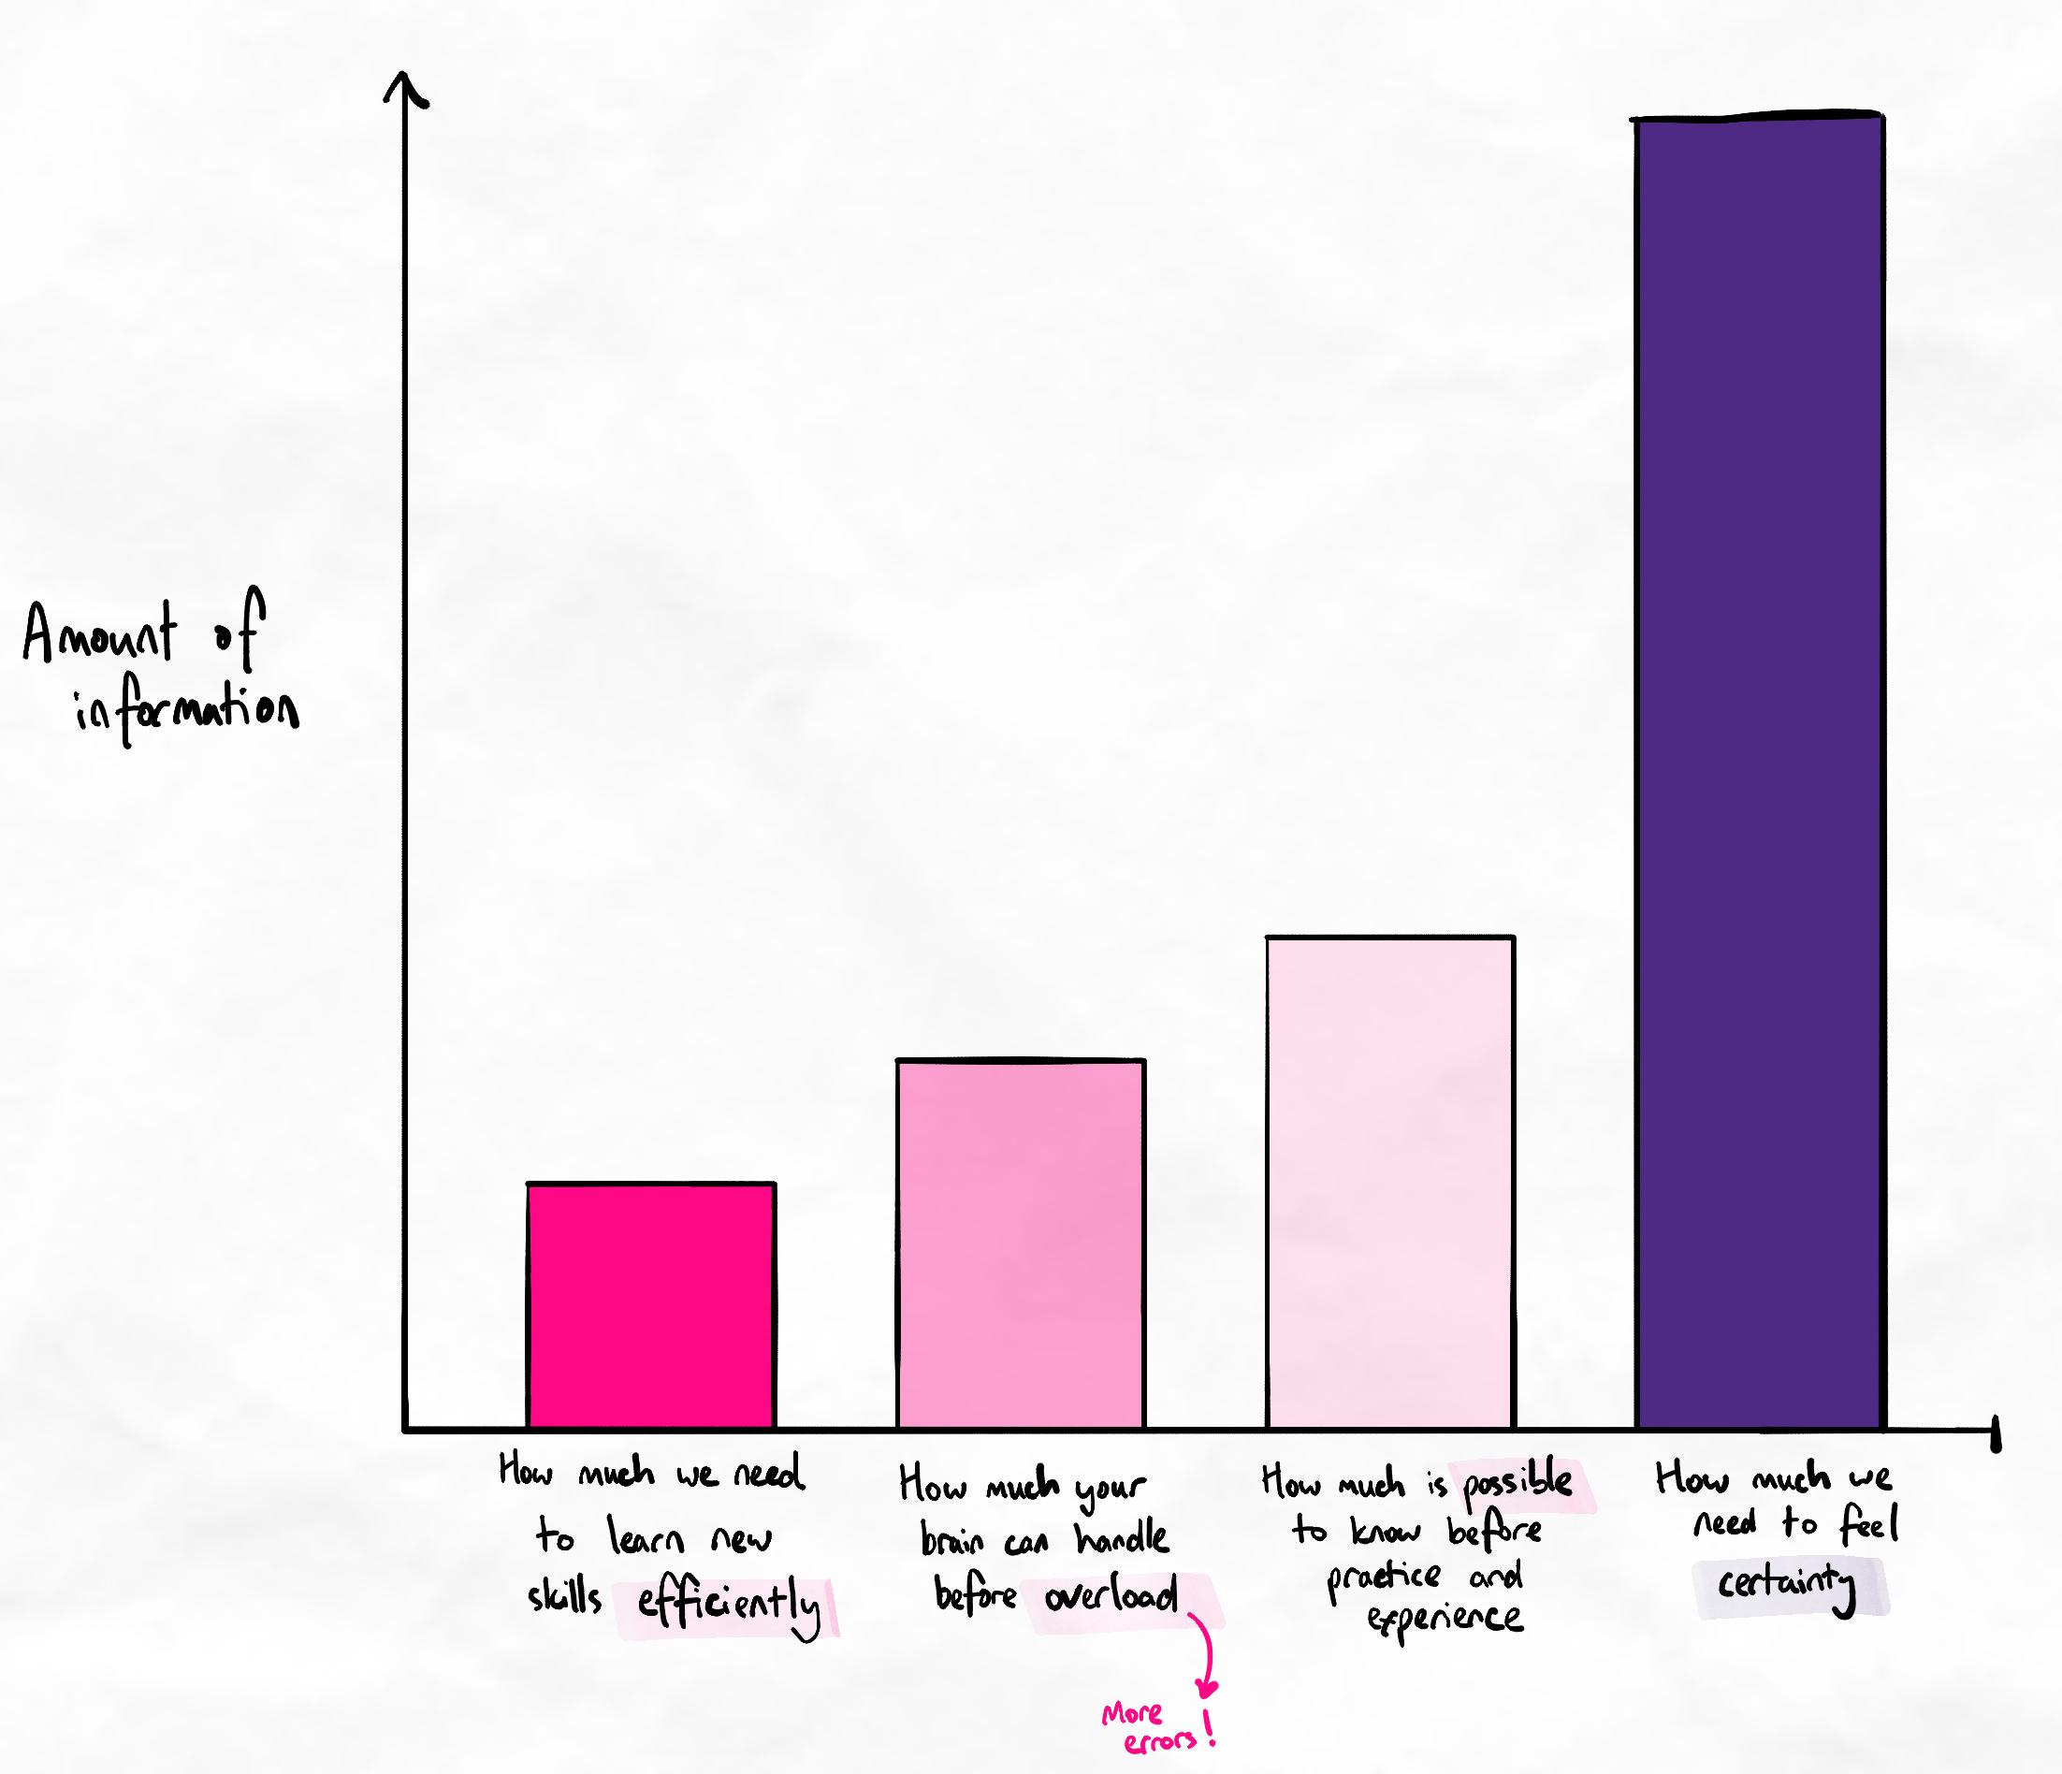View the full article on information vs. experimentation here.
Asking questions is an important part of learning. Questions about new methods are helpful when they help you gain clarity over the process. Questions that ask about "what if" scenarios to reduce the risk of mistakes that may never occur are not helpful.
Question 3.2
Choose the statement that reflects the best path of action for Sourabh to improve.
First, he must recognise that he is asking "what if" questions to avoid making mistakes.
First, he must find the right resources and videos that give him enough information.
First, he must ask more targeted questions that give him the certainty that he needs to proceed.
Ans: First, he must recognise that he is asking "what if" questions to avoid making mistakes.
Choose the statement that reflects the best path of action for Sourabh to improve.
Second, he must imagine using the new methods to think of additional questions.
Second, he must experiment with these new methods to decide if they are worth using or not.
Second, he must experiment with these new methods to identify mistakes and issues.
Ans: Second, he must experiment with these new methods to identify mistakes and issues.
Choose the statement that reflects the best path of action for Sourabh to improve.
Third, he must evaluate how effective they are through his next exam results.
Third, he must quickly decide if the method is useful or not. If not, he must try a different method.
Third, he must reflect and refine the method, while testing the effectiveness frequently.
Ans: Third, he must reflect and refine the method, while testing the effectiveness frequently.

